420-D10-HR
D10_S07_A01
Activity 01: Modeling diagrams with Crow’s foot notation

Objectives:
Become familiar with drawing Entity Relationship Diagrams with Crow’s foot notation.

To Do: (Walkthrough one use case with professor)
- The class will be divided into teams of 2 students; Student 1, Student 2
- Student’s take turns modeling (either drawing on paper, tablet or whiteboard).
- Alternating between who draws and who interprets.
- Warning: you have to think beyond the requirements given to fully model the entities and the relationship to describe the real world.

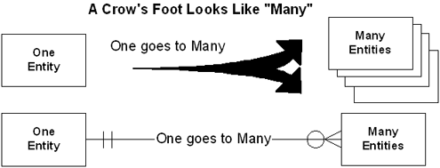

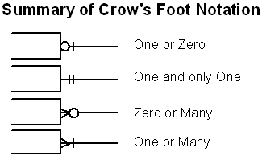

Student 1:
- A woman may give birth to none or many children
- Bicycle belongs to a person.
- A students takes subjects.
- Subjects may have 0 or more books. Books are not shared amongst students. Students take subjects. Students own books.

Student 2:
- Dog squats out poop.
- A wing at Heritage can have one or more network printers
- A person owns a pair of underwear.
- A class has students. A class is taught by one teacher.

